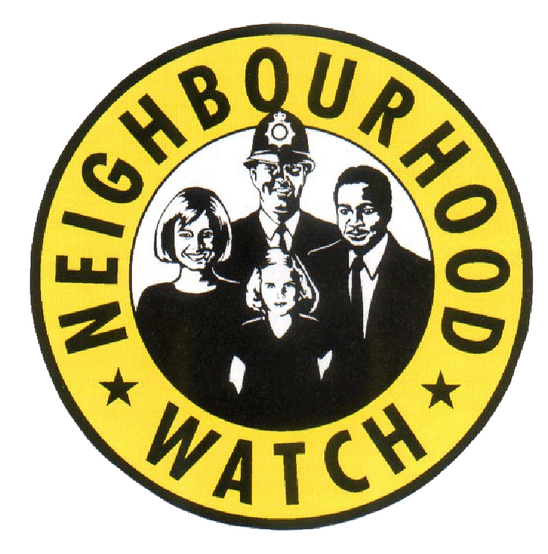

EAST RIDING NEIGHBOURHOOD WATCH

December 2018

Dear Coordinators

I would like to take this opportunity to wish you all Season’s Greetings and thank you for all the work you have done in 2018.

I would also like to say thank you and welcome to the new groups that have signed up since the end of October:
Breighton Road Bubwith, Tweengates Close Pocklington. Helms Avenue/Station Road Preston, Cave Castle Hotel South Cave, Cranbeck Close Bridlington

Unfortunately we have not been able to find replacement coordinators for the following areas and these groups will be disbanded on 2nd January 2019.
Bridlington:
Bright Crescent/Avocet Way/Nightingale Road/Woburn Close
Cottingham:
Barker Close
Goole:
Alexander Street
Hessle:
Astral Road
Withernsea:
Holmpton Road, Newsham Gardens and Hollym Road
Beverley:
Grayburn Lane/Holderness Crescent

Bishop Burton:
Neighbourhood Watch in the East Riding has made a lot of progress this year and below are just two examples of many achievements:

Bishop Burton:
NHW Bishop Burton have set a great template for how rural communities can develop crime resilience. After meeting myself and the police earlier this year we identified the issues in the village and developed a crime action plan. The Coordinators organised a Crime Prevention Event, entitled Are your valuables safe? Concerned about theft? The event goal was to share information about crime prevention and the Safe & Sound Grant. The police supported residents to register on My Community Alert and Immobilise. NHW are currently working with their local Primary School on a speed awareness initiative to be launched in the new year.

Bridlington:
Bridlington NHW Coordinators have worked hard to support myself and the police to get as many Bridlington Early Intervention and Prevention Community Safety Surveys completed as possible and increase both community engagement and the number of NHW groups in the town. Bridlington Neighbourhood Watch have also formed a charity. This charity will become part of the existing Bridlington Crime Prevention Group.

I Need Your Feedback:
As you know we have developed a number of Community Led Crime Action Plans across the East Riding. Some of the issues raised are county wide so I have developed an information pack. This pack includes a number of frequently asked questions and an over view of some of the services that are available to deal with the issues that concern you most.

I am looking for about 20 coordinators to volunteer to read and feedback on the current daft. Before I start sending them out I need to be aware of any information gaps.

If you would like to be part of the consultation/feedback then please let me know by Friday 4th January 2019.

Scam Warning: There are many scams and reports of scams and they are often a variation on the same theme however now and again a new type pops up. Therefore I do try to send you any of particular interest or with a new angle.

“A lady opened a webpage (books4you.zone) on her
phone and it triggered a £4.50 text. There was also a text informing
her this would be charged on a weekly basis unless she texted STOP!
She spoke to her provider (Tesco) and they refunded her money and
advised her to text STOP. Apparently this is the latest scam and can
occur on the most innocuous websites. She has now spoken to Tesco to
put a block on premium rate numbers and adult text services on all
their family phones. You might consider taking the same action with
your phone provider.”

CRIMESTOPPERS:
While improvements are being made to the non-emergency number please use Crime stoppers to report criminal activity on 0800 555 111. However, if you require urgent police attention call 999.

Crime Reduction Advice From Humberside Police
“Keep your presents off the burglars list this Christmas.

Well it’s that time of year again, the trees are going up, the Christmas lights are being turned on, those Christmas decorations that have been on display in most of our larger shops since September now look relevant, and the festive adverts are on the TV again and again.

Yes, Christmas is here and with it, the excitement and the frantic rushing around have begun in earnest. It’s a time when everything goes up a gear. We’re in a hurry; we need to do loads of things; we have so much to plan. But, if we’re not careful, whilst doing all of these things, we can become careless and lose sight of those simple crime prevention measures that we practice all year.

Just as Christmas is a busy time for everyone, it can equally be a time of plenty for the opportunist thief if we let them take advantage of our rushing around. Follow these simple steps to avoid becoming a target for crime and have a crime free Christmas and New Year.

• If out shopping, don’t leave any shopping bags, coats or other items on view in your car, always ensure that they are out of view by placing them in the car boot.

• Always try and park in a well-lit car park or street and check that your car is secure!

• Consider your home security too - don’t leave the curtains open and all your presents and Christmas tree on display whilst you’re out.

• If you can, leave a radio on and put lights on timer switches to ensure that it looks like that someone is at home.

• Ensure your property is secure by making sure that your garage door, house doors, garden sheds/outbuildings and windows are all locked. Try not to leave any keys in locks as glass can be smashed, keys taken and then used to open doors or windows to gain entry.

• If you are going away over the festive period then consider asking a trusted neighbour or family member to come round and open and close curtains, plus move the post, so it looks like people are coming and going at your home. Also don't advertise that you are away. Social networking sites like Facebook and Twitter can be a risk if people know you are away and your home is empty.

• Remove and secure items that may be used to break in or climb into your home (eg spades and ladders). Garden tools, DIY equipment and leisure items such as fishing and golf equipment should ideally be locked away in storage cupboards within outbuildings to form a second line of defence to thieves.

• Motorbike and pedal cycles should also be locked even when they are in a shed or garage.

• If you have a household alarm consider extending it to cover your outbuildings, fit a bespoke shed/garage alarm or buy an inexpensive, but effective battery operated shed alarm. Anything which makes a loud noise will send a thief running!

• Lastly for reference, record a description and add photographs of your bicycles, golf clubs, fishing equipment, tools, jewellery and any other valuable property on www.immobilise.com. Neighbourhood Watch co-ordinators – December 2018”

Make Time for Winter

East Riding of Yorkshire Council is encouraging residents to stay safe and warm this winter by planning in advance of any bad weather.
With over 2,000 miles of roads in the East Riding the council cannot guarantee to keep every road open during bad weather. We treat the precautionary network which covers around 38 per cent of all our roads, about 800 miles. To see which roads in the East Riding are routinely treated in case of ice and snow visit www.eastriding.gov.uk/winter
You could also exchange telephone numbers with the more vulnerable people in your neighbourhood in case they need you in an emergency. You may be able to help with shopping if they are worried about going out when it is icy or maybe you could provide a friendly voice when it is cold and miserable.
It would also be a good idea to buy some salt for footpaths and steps as anyone can clear snow and ice from the pavement outside their home or public spaces to prevent slips and falls. Don’t be put off clearing paths because you’re afraid of legal action. Remember, people walking on snow and ice have a responsibility to be careful themselves.

Crime Prevention Shop
A reminder that Hull Neighbourhood Networks have an on line shop where you can buy all sorts of crime prevention items.
Here’s the link
https://www.nnetwork.org.uk/shop/

There are a number of items available including card protectors which will stop fraud by blocking access to the magnetic strip on your card which if accessed can result in your card details being duplicated.
we sell them at a £1.00 each!

The coupon code is ERMEMBER so that the groups in the East Riding can get the discount. Just add the coupon code when prompted and the discount will be taken off,
The current discount is £1.00 per item and currently £5.00 off the cycle lock. We have set up postage with Hermes but they can offer collection from their base at Zeal’s Garth Hull free of charge.

And Finally … The date of the Neighbourhood Watch Annual Networking Event is Saturday 27th April 2019.

You can put the date in your diary now and I will be sending the formal invitations out in the new year.

This year we are focusing on Anti-Social Behaviour and meeting some of the partners we work with to tackle ASB and also prevent it happening. The format will be more interactive and I will send more details about that in January.

The next NHW Newsletter will be the overview of the Neighbourhood Watch Networking Event and the deadline for coordinator contributions will be Tuesday 23rd April 2018.

Maureen Yates Community and Crime Reduction Resilience Officer
Housing and Public Protection, East Riding of Yorkshire Council, County Hall, Cross Street, Beverley
HU17 9BA
Telephone: 01482 391013
Mobile: 07899 061213
Maureen.yates@eastriding.gcsx.gov.uk

